2BPHY: Electrical Fundamentals TEST 2010 for year 11 students

Name: _____________________________________ (48 marks total)
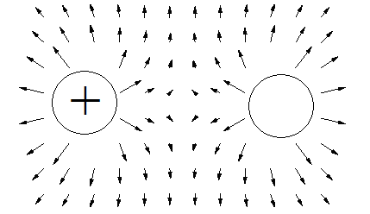
- The diagram shows two charged particles and the field that surrounds them. Using the information in the diagram determine the charge on the other sphere

Positive
(1 mark)

- Which of the following graphs could represent an ohmic conductor? (1 mark)
Answer:
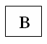

A B C D

- Calculate the resistivity of a metal alloy wire if a sample with cross-sectional diameter 0.200 mm and length 2.50 m has a measured resistance of 88.8 Ω. (3 marks)

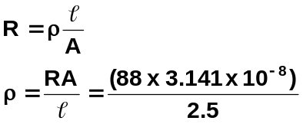Diam = 0.2 mm
r = 1.0 x 10⁻⁴ m
A = πr²
= 3.141 x 10⁻⁸ m²
l = 2.5 m
R = 88 Ω
ρ = 1.11 x 10⁻⁶ Ωm

4. A lightning bolt transfers 30.0 C of charge to the Earth through a potential difference of 2.00 x 10⁸ V. During this time, the lightning strike lasts for a time of only 1.50 ms.

a. How much energy is dissipated in this lightning strike? (2 marks)

q = 30 C W = Vq
V = 2 x 10⁸ V = 2 x 10⁸ x 30
t = 1.5 x 10⁻³ s W = 6.0 x 10⁹ J

b. What is the average power developed during the strike? (2 marks)

I =  P = 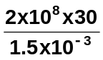
And P = VI
P = 4.0 x 10¹² W
P = 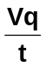
- The element of an electric jug has a resistance of 545 Ω and draws a current of 2.50 A. 750 mL of water at a temperature of 18.0⁰C is in the jug. How long will it take to bring the water to the boil (100⁰C)? (3 marks)

R = 545 Ω Electrical energy = heat energy
I = 2.50 A VIt = mcΔT
V = IR 1362.5 x 2.5 x t = 0.75 x 4180 x (100 – 18)
= 545 x 2.5 3406.25t = 257070
= 1362.5 V t = 75.47

t = 75.5 s

- The circuit diagram below shows a two-way switch wired to a single globe.

globe
Neutral

Active
Switch 1 Switch 2

With the switch positioned as shown, is the globe “on” or “off”? OFF ( 1 mark)
Name a situation where you would use a two-way switch. e.g. hallway (1 mark)
- a. A force of 8.50 x 10⁻³ N attraction is felt between two charged spheres that are 45.0 cm apart. If one has a charge of + 0.300 μC, what is the charge on the other? (3 marks)

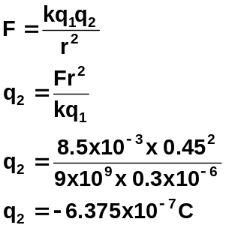
NOTE: must have negative sign for full marks

The two spheres are then forced together and allowed to separate to a distance of 30.0 cm apart. What is the force between the two spheres now? (3 marks)

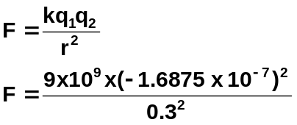+3.0 -6.375

3.0 – 6.375

-1.6875 -1.6875
F = 2.85 x 10⁻³ N repulsion
NB: if use +6.375 above
answer becomes 2.20 x 10⁻² repulsion

8. Electric blankets are usually fitted with three heat settings:
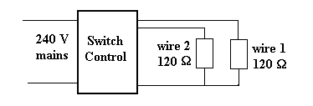
- If only wire 1 is connected to the 240 V supply, what is the current from the supply? (2 mark)

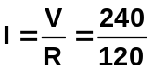
I = 2.0 A

- If wires 1 and 2 are connected in series, what is the current drawn from the supply? (2 marks)

R_{T} = 120 + 120 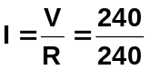
R_{T} = 240
I = 1.0 A

- If wires 1 and 2 are connected in parallel, what is the current drawn from the supply? (2 marks)

R_{T} = (120⁻¹ + 120⁻¹)⁻¹ 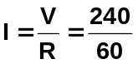
R_{T} = 60 Ω I = 4.0 A

- Explain how the electric blanket can be operated on different heat settings. (2 marks)
The greater the resistance the greater the current and hence the greater the heating.
By changing wires used and if in series or parallel, current can change and so can heating effect.

- Draw a circuit that has two 50 Ω resistors in parallel with each other. A 20 Ω resistor is in series with one of the 50 Ω resistors within the parallel section. A 100 Ω resistor is in series with the parallel. An ammeter is set up to measure the current through the whole circuit and a voltmeter is set up to measure the potential difference across the 20 Ω resistor. A 12 V power pack is used to run the circuit. Draw the circuit. (3 marks)

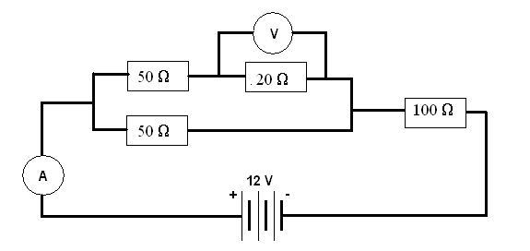
10. A student completes a circuit that includes a mystery box as shown below.
1. Find current: I = V/R = 8/50 = 0.168 A
2. For box: V = 12 – 8 = 4 V R = V/I = 4/0.16
I = 0.16 A R = 20 Ω
For A: wrong resistance
For B: (25⁻¹ + 25⁻¹)⁻¹ = 12.5 Ω
For C: short circuit
For D: (50⁻¹ + 50⁻¹)⁻¹ = 25 Ω so correct answer

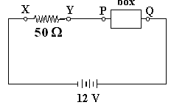
If the potential difference between X and Y is 8.0 volts, which of the following boxes (A - D) is in
the circuit? (3 marks)
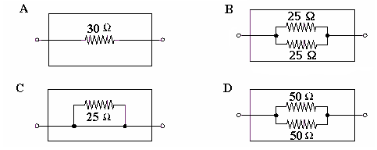

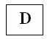

Answer

11. Three resistors, having resistances of 20 Ω, 30 Ω and 50 Ω are connected in series across a 12 V power supply. Calculate
a. The total resistance. (1 mark)

R = 20 + 30 + 50
R = 100 Ω

b. The current flowing in each resistor. (1 mark)

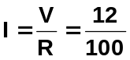
I = 0.12 A

c. The potential difference in the 30 Ω resistor. (1 marks)

V = IR
V = 0.12 x 30
V = 3.6 V

The resistors are then connected in parallel. Find
d. The total resistance. (2 mark)

R = (20⁻¹ + 30⁻¹ + 50⁻¹)⁻¹
R = 9.7 Ω

e. The current through the 30 Ω resistor. (2 marks)

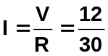
I = 0.40 A
- An electrical engineer has set up the following circuit in an electrical device. By showing your working below and writing your answers in the spaces provided:

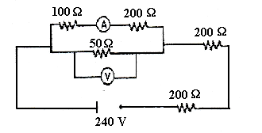
- Determine the total resistance of the circuit. (2 marks) Answer: 443 Ω
b. What is the reading on the voltmeter? (3 marks) Answer: 23.2 V
c. What is the reading on the ammeter? (2 marks) Answer: 0.077 A

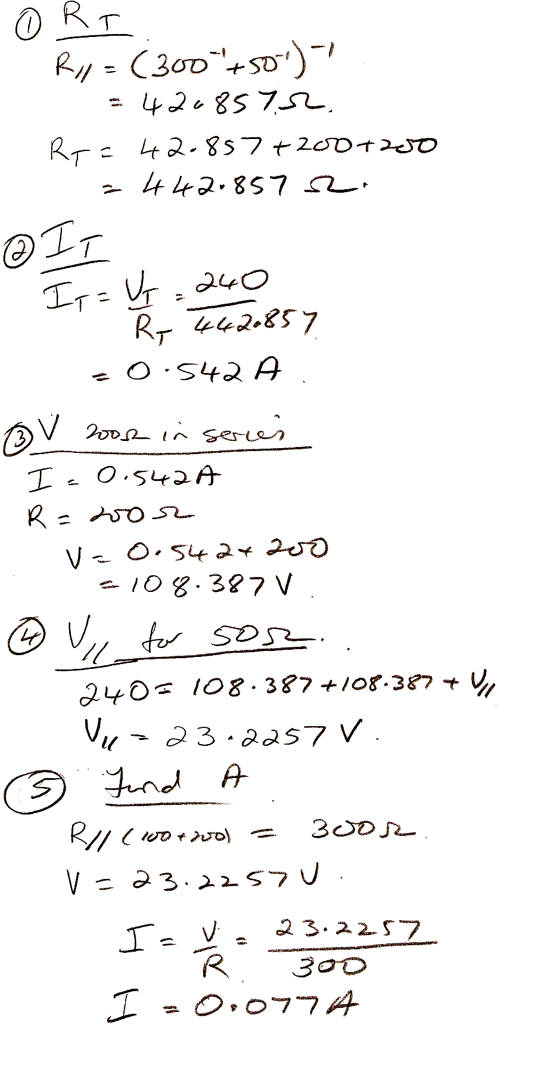

BONUS QUESTION.
Do not attempt this question until all the others are answered. Bonus question is worth 5 marks.
